**#] Become Familiar with Version Management, Open Source repos and Basics of Github**

1. **Understanding Version Management System - Git Tutorial Part 1:What is version control**

[**https://www.youtube.com/watch?v=9GKpbI1siow**](https://www.youtube.com/watch?v=9GKpbI1siow)

1. **Learn more on Version control system – BitBucket**

[**https://bitbucket.org/product/version-control-software**](https://bitbucket.org/product/version-control-software)

1. **Become familiar with code Repository Tools and their uses.**

[**https://www.softwaretestinghelp.com/version-control-software/**](https://www.softwaretestinghelp.com/version-control-software/)

1. **Become Familiar with GitHub Usage and Installation**

[**https://git-scm.com/book/en/v2/Getting-Started-Installing-Git**](https://git-scm.com/book/en/v2/Getting-Started-Installing-Git)

1. **Creating a repository in GitHub under your profile.**

[**https://www.atlassian.com/git/tutorials/setting-up-a-repository**](https://www.atlassian.com/git/tutorials/setting-up-a-repository)

1. **Learn how to perform PUSH and PULL request - Git Tutorial Part 1:What is version control**

[**https://www.youtube.com/watch?v=n-p1RUmdl9M&t=1s**](https://www.youtube.com/watch?v=n-p1RUmdl9M&t=1s)

1. **Understand more about PUSH and PULL**

[**https://www.datacamp.com/community/tutorials/git-push-pull**](https://www.datacamp.com/community/tutorials/git-push-pull)

**#] Understand how to fork a repo .**

1. **Understanding Github Repo structure**

[**https://help.github.com/en/github/getting-started-with-github/fork-a-repohttps://help.github.com/en/github/getting-started-with-github/fork-a-repo**](https://help.github.com/en/github/getting-started-with-github/fork-a-repo)

**#] Gain Hands on Experience with Basics Operations of Github.**

1. **Add a file(text file) to the repo.**

[**https://help.github.com/en/github/managing-files-in-a-repository/managing-files-using-the-command-line**](https://help.github.com/en/github/managing-files-in-a-repository/managing-files-using-the-command-line)

1. **Delete file in Repo**

[**https://www.jquery-az.com/remove-file-directory-git/**](https://www.jquery-az.com/remove-file-directory-git/)

1. **Know about gist creation.**

[**https://www.labnol.org/internet/github-gist-tutorial/28499/**](https://www.labnol.org/internet/github-gist-tutorial/28499/)

1. **What is Markdown.**

[**https://guides.github.com/features/mastering-markdown/**](https://guides.github.com/features/mastering-markdown/)

**#] Explore virtual labs.**

1. **Virtual labs**

[**http://vlab.co.in/**](http://vlab.co.in/)

[**Data Structures Lab**](http://cse01-iiith.vlabs.ac.in/)

1. **Log issues on Virtual labs.**

[**https://docs.google.com/document/d/155ueBnjThk2ur1HBqDuqSAuYfZZc7h9A4BeU-_XRvJc/edit**](https://docs.google.com/document/d/155ueBnjThk2ur1HBqDuqSAuYfZZc7h9A4BeU-_XRvJc/edit)

**#] Understand HTML and Create user Interface.**

1. **Introduction to HTML.**

[**https://www.w3schools.com/html/html_intro.asp**](https://www.w3schools.com/html/html_intro.asp)

1. **Learn more on basic of HTML**

[**https://www.w3schools.com/html/html_basic.asp**](https://www.w3schools.com/html/html_basic.asp)

1. **Become familiar with Image tags.**

[**https://www.w3schools.com/html/html_images.asp**](https://www.w3schools.com/html/html_images.asp)

1. **Learn more on Lists.**

[**https://developer.mozilla.org/en-US/docs/Web/HTML/Element/ol**](https://developer.mozilla.org/en-US/docs/Web/HTML/Element/ol)

[**https://www.w3schools.com/html/html_lists.asp**](https://www.w3schools.com/html/html_lists.asp)

1. **Understand more about Anchor tags.**

[**https://www.w3.org/MarkUp/1995-archive/Elements/A.html**](https://www.w3.org/MarkUp/1995-archive/Elements/A.html)

1. **Learn more about Tables.**

[**https://htmldog.com/guides/html/advanced/tables/**](https://htmldog.com/guides/html/advanced/tables/)

[**https://www.w3schools.com/html/html_tables.asp**](https://www.w3schools.com/html/html_tables.asp)

1. **Become familiar with Divisions.**

[**https://developer.mozilla.org/en-US/docs/Web/HTML/Element/div**](https://developer.mozilla.org/en-US/docs/Web/HTML/Element/div)

[**https://www.w3schools.com/tags/tag_div.ASP**](https://www.w3schools.com/tags/tag_div.ASP)

1. **Learn more about iFrame.**

[**https://www.lifewire.com/when-to-use-iframes-3468667**](https://www.lifewire.com/when-to-use-iframes-3468667)

[**https://www.w3schools.com/tags/tag_iframe.asp**](https://www.w3schools.com/tags/tag_iframe.asp)

**#] Master the use of Form and Form Attributes.**

1. **Know about Forms.**

[**https://www.w3schools.com/html/html_forms.asp**](https://www.w3schools.com/html/html_forms.asp)

1. **Create form elements with inputs.**

[**https://www.w3schools.com/html/html_form_elements.asp**](https://www.w3schools.com/html/html_form_elements.asp)

[**https://www.w3schools.com/html/html_form_input_types.asp**](https://www.w3schools.com/html/html_form_input_types.asp)

1. **Form Attributes.**

[**https://www.w3schools.com/html/html_form_attributes_form.asp**](https://www.w3schools.com/html/html_form_attributes_form.asp)

1. **Html validator**

[**https://validator.w3.org/**](https://validator.w3.org/)

1. **Learn more on Form elements.**

[**https://www.youtube.com/watch?v=S-vTL8jWFWs**](https://www.youtube.com/watch?v=S-vTL8jWFWs)

**#] Explore the header and Footer Section**

1. **Google form**

**Select 8 links in 4 labs and fix them**

[**https://docs.google.com/spreadsheets/d/1YDme4JWGL-MNnAxbCXbb0rhXa1o-GcM0Ux3lBGnxD3A/edit#gid=1614439655**](https://docs.google.com/spreadsheets/d/1YDme4JWGL-MNnAxbCXbb0rhXa1o-GcM0Ux3lBGnxD3A/edit#gid=1614439655)

1. **Repair Header Section**

[**https://docs.google.com/spreadsheets/d/1YDme4JWGL-MNnAxbCXbb0rhXa1o-GcM0Ux3lBGnxD3A/edit#gid=1614439655**](https://docs.google.com/spreadsheets/d/1YDme4JWGL-MNnAxbCXbb0rhXa1o-GcM0Ux3lBGnxD3A/edit#gid=1614439655)

[**http://ps-iiith.vlabs.ac.in/exp2/Introduction.html?domain=Computer%20Science&lab=Problem%20Solving%20Lab**](http://ps-iiith.vlabs.ac.in/exp2/Introduction.html?domain=Computer%20Science&lab=Problem%20Solving%20Lab)

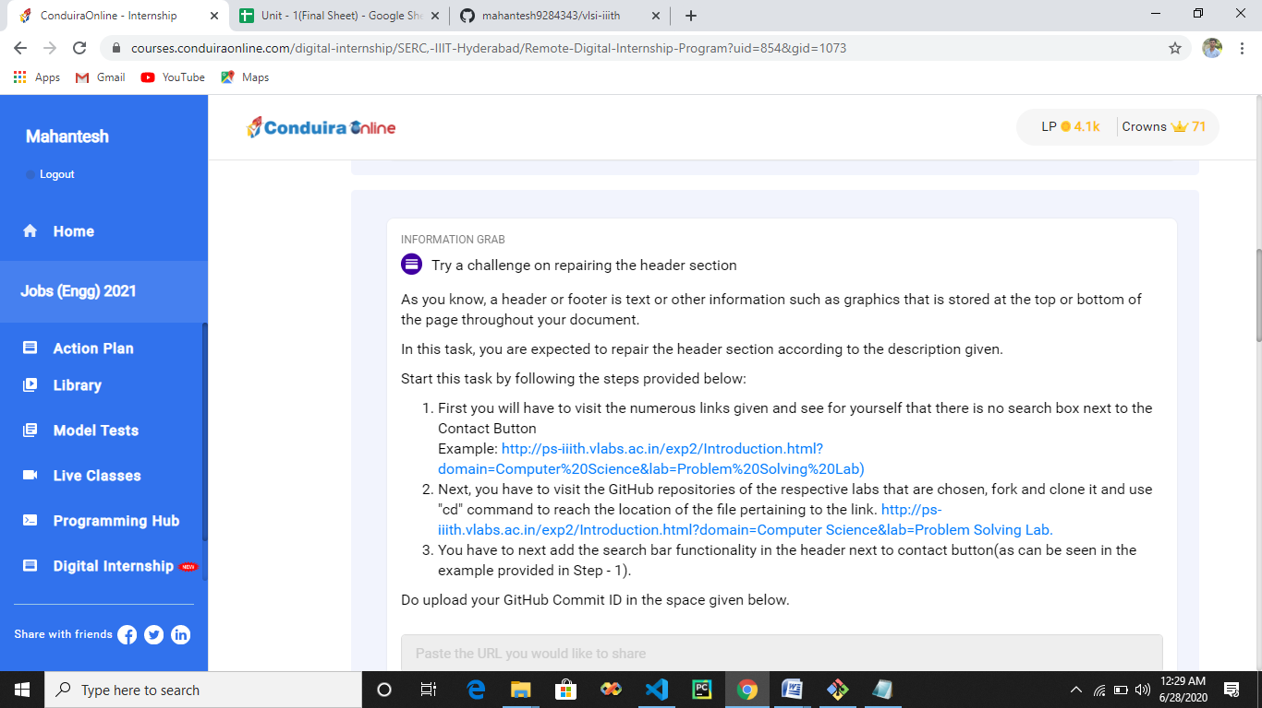

**#] Master styling the web page using CSS**

1. **Get Introduction to CSS**

[**https://www.w3schools.com/css/default.asp**](https://www.w3schools.com/css/default.asp)

1. **Learn more on CSS**

[**https://www.youtube.com/watch?v=yfoY53QXEnI**](https://www.youtube.com/watch?v=yfoY53QXEnI)

1. **Understand Web development**

[**https://developer.mozilla.org/en-US/docs/Learn**](https://developer.mozilla.org/en-US/docs/Learn)

1. **Become Familiar with Background**

[**https://www.w3schools.com/css/css_background.asp**](https://www.w3schools.com/css/css_background.asp)

1. **Get a sneak peek into texts.**

[**https://www.w3schools.com/css/css_text.asp**](https://www.w3schools.com/css/css_text.asp)

1. **Understand more about Fonts**

[**https://www.w3schools.com/css/css_font.asp**](https://www.w3schools.com/css/css_font.asp)

1. **Learn more about Links**

[**https://www.w3schools.com/css/css_link.asp**](https://www.w3schools.com/css/css_link.asp)

1. **Become familiar with Lists**

[**https://www.w3schools.com/css/css_list.asp**](https://www.w3schools.com/css/css_list.asp)

1. **Understand more about margins**

[**https://www.w3schools.com/css/css_margin.asp**](https://www.w3schools.com/css/css_margin.asp)

1. **Learn more on Outlines**

[**https://www.w3schools.com/css/css_outline.asp**](https://www.w3schools.com/css/css_outline.asp)

1. **Get a sneak peek into padding**

[**https://www.w3schools.com/css/css_padding.asp**](https://www.w3schools.com/css/css_padding.asp)

1. **Get and Introduction to selectors**

[**https://www.w3schools.com/css/css_attribute_selectors.asp**](https://www.w3schools.com/css/css_attribute_selectors.asp)

1. **Understand more about Display**

[**https://www.w3schools.com/css/css_display_visibility.asp**](https://www.w3schools.com/css/css_display_visibility.asp)

1. **Learn about Positioning**

[**https://www.w3schools.com/css/css_positioning.asp**](https://www.w3schools.com/css/css_positioning.asp)

1. **Become familiar with Float**

[**https://www.w3schools.com/css/css_float.asp**](https://www.w3schools.com/css/css_float.asp)

1. **Know more about align**

[**https://www.w3schools.com/css/css_align.asp**](https://www.w3schools.com/css/css_align.asp)

1. **Understand more about navigation bar**

[**https://www.w3schools.com/css/css_navbar.asp**](https://www.w3schools.com/css/css_navbar.asp)

1. **Learn more about Tables**

[**https://www.w3schools.com/css/css_table.asp**](https://www.w3schools.com/css/css_table.asp)

**#] Google Form**

**1]**

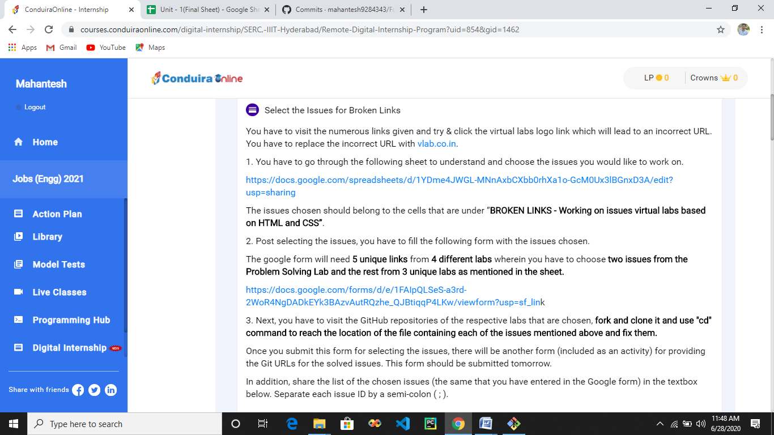

**2]**

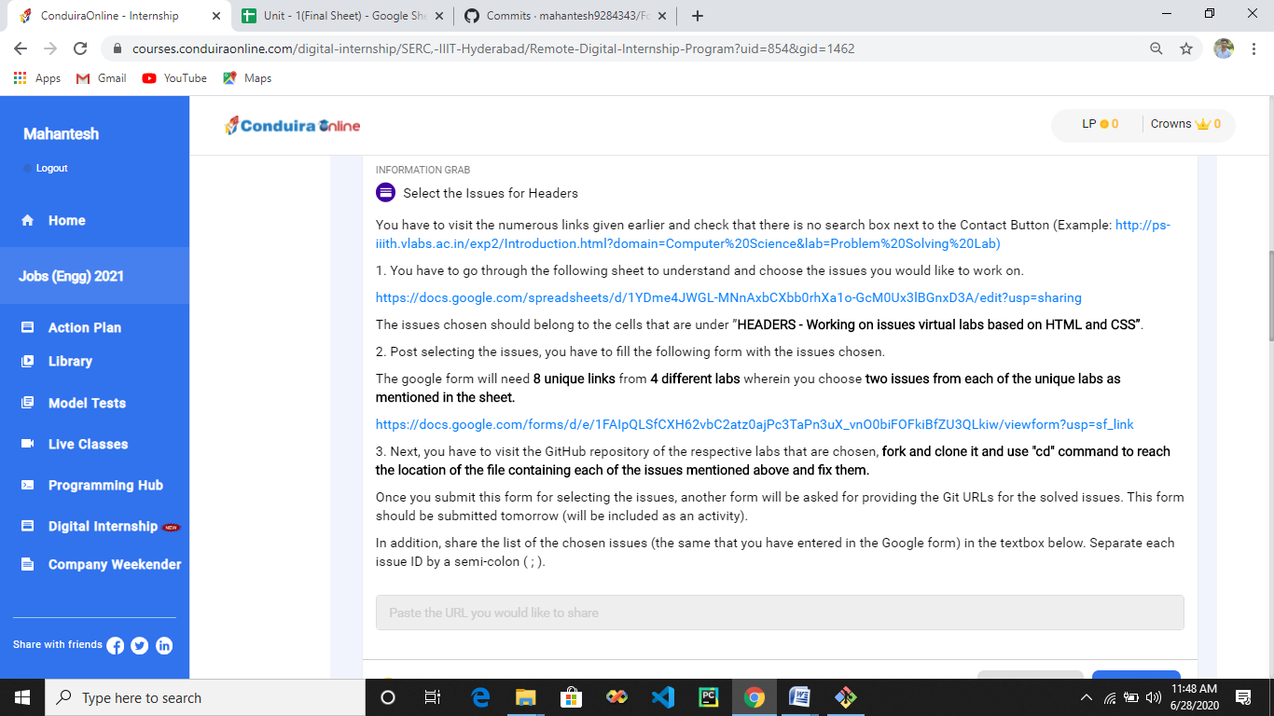

**3]**

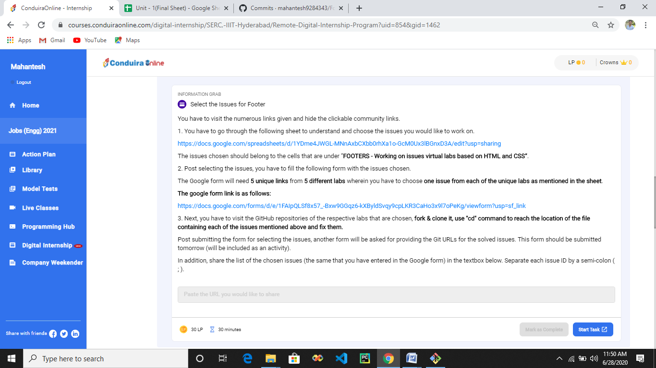

**4]**

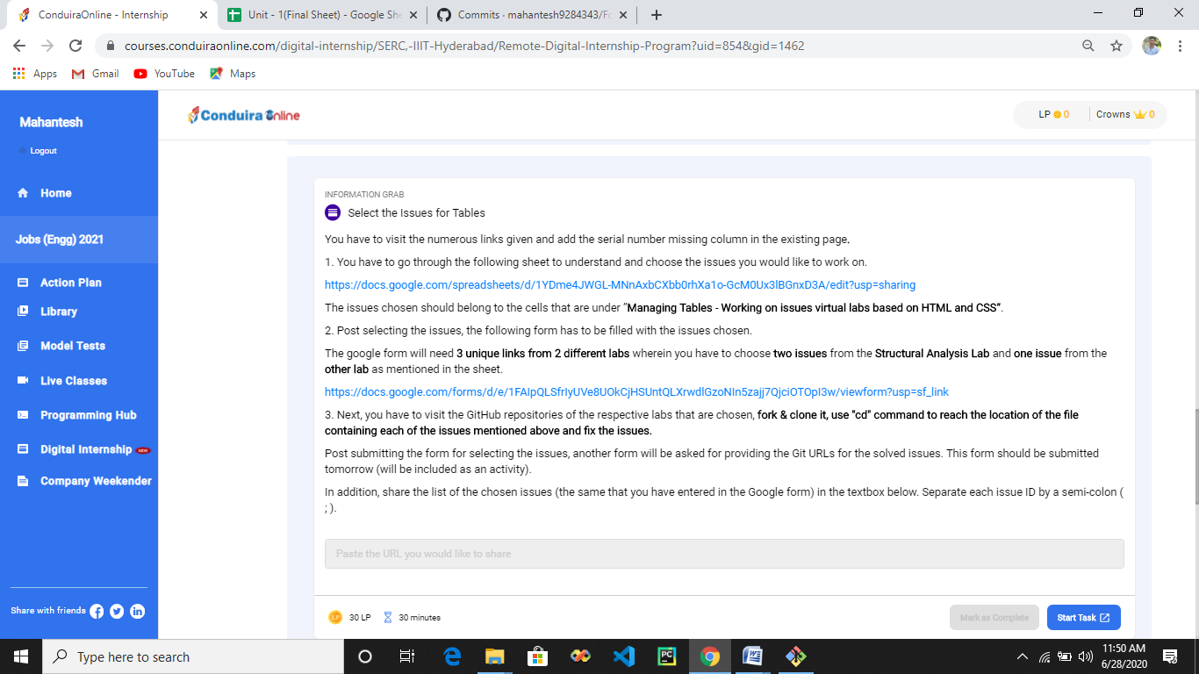

**5]**

